

Darsena
residency #2
Project weeks @ Galleria Massimodeluca
03 June - 15 July 2016

Open call until 15 April 2016
Online application form: www.massimodeluca.it

project by
Paolo Brambilla
Stefano Cozzi

"The darsena, or dock, is a house for work, a workshop, a place in which boats are constructed but also where they come to rest. In the same way, the Galleria Massimodeluca is a space for relationships and activities which during the residency also becomes a home. And this home itself looks onto a Dock, in this area where the mainland and the lagoon meet, and this is one of the reasons that this place has been chosen”.

These are the words used by Marina Bastianello when presenting the second edition of Darsena residency, the innovative residency project, unique in Italy, conceived and promoted by Galleria Massimodeluca: Darsena residency #2 (from 3 June to 15 July 2016); they are a confirmation of the concept behind the 2015 edition - for the artists chosen will not only work, but will live together in the exhibition space which will thus becomes a space for relationships, contaminations, and comparisons - but the 2016 residency will have more content and opportunities thanks to the project developed by the artists Paolo Brambilla and Stefano Cozzi.

Open call is open until 15 April 2016 and the application form can be downloaded from www.massimodeluca.it. All artists born after 1 January 1980, whether graduates or about to graduate, can apply.

Darsena residency #2 is organised into three sessions of ten days each, distributed over a month and a half, and will have as its protagonists four young artists. Each session will be introduced by a team consisting of the curators Valentina Lacinio and Claudio Piscopo and the co-ordinating artists Brambilla and Cozzi; they will suggest a working theme and will also be concerned with the final criticism of the works produced. The project will also organise studio visits, studios open to the public, at the end of each work session, and a final exhibition with a catalogue.

The studio visits will be organised by Simone Frangi (curator), Nicola Setari (curator), Renato Alpegiani (collector), and Catherine Biocca (artist).

Just as was the case in the summer of 2015, when the works by Barbara Prenka and Orianne Castel could be seen side by side, the aim of the residency is to incentivise a dynamic and versatile approach to facing artistic research, so allowing the artists to deepen, both together with their colleagues and with the curators, their own personal methods of work. This is a process of production and relationships stimulated by three macro-themes that are very topical in research processes and which artists already have to deal with in their art: Appropriation (first session 6-16 June), Resistance (second session 20-20 June), and 2046 (third session 4-14 July).

The selection committee consists of Marina Bastianello, Paolo Brambilla, and Stefano Cozzi (coordinators), Valentina Lacinio, and Claudio Piscopo (curators). The names of the artists selected will be made known before 29 April 2016.

For information

From Monday to Friday 10 a.m. to 5 p.m.
Saturday by appointment
Via Torino 105/q
30170 Venezia Mestre
mobile phone +39 338 7370628
mobile phone +39 366 6875619
info@massimodeluca.it
www.massimodeluca.it

Press information
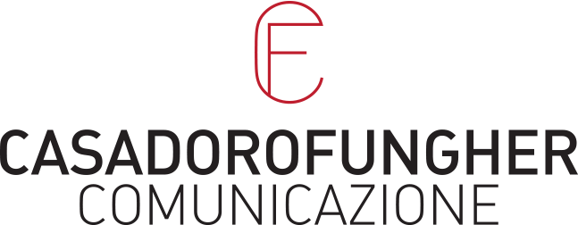
Francesca Fungher
m +39 349 3411211
francesca@casadorofungher.com
Elena Casadoro
m +39 334 8602488
elena@casadorofungher.com
www.casadorofungher.com

